QXtend Inbound introduction
WCE Sangli, Intern @Eaton

[Pick the date]

Regoti, Sujata
QXtend Inbound introduction
WCE Sangli, Intern @Eaton

QXtend Inbound
Open Link of QXtend Inbound http://ascqa.tcc.etn.com:8081/asc1qxi163/
When we open Inbound, we get options as follows:
- Managers
- Functions
3 Tabs : License , Configuration , Connections. These options can also found under Managers option as shown in fig. 1.
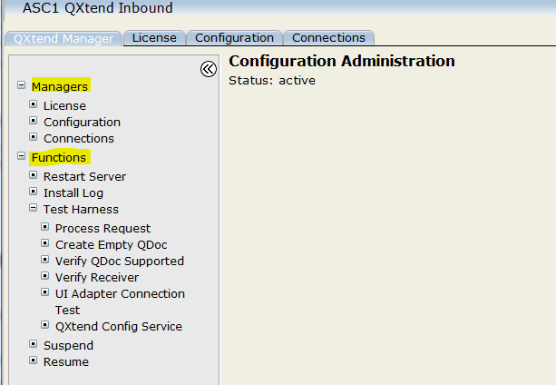fig. 1
- MANAGERS
Let’s 1st go through Managers option. We have
- License : QXtend needs license code to communicate with third party products.
- Configuration : To ensure that messages can be processed into a target QAD application
- Connections : QXI connection pools provide connections from QXtend to specific instances of QAD applications

- License
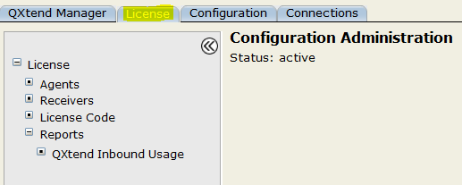

Under License we have :
  - Agents : Agents move data into and out of the system. Agents listen for requests to transmit data, gather the data to transmit, and deliver it to the receiver.

  - Receivers : A receiver is a destination or endpoint for data transmitted via QXtend.

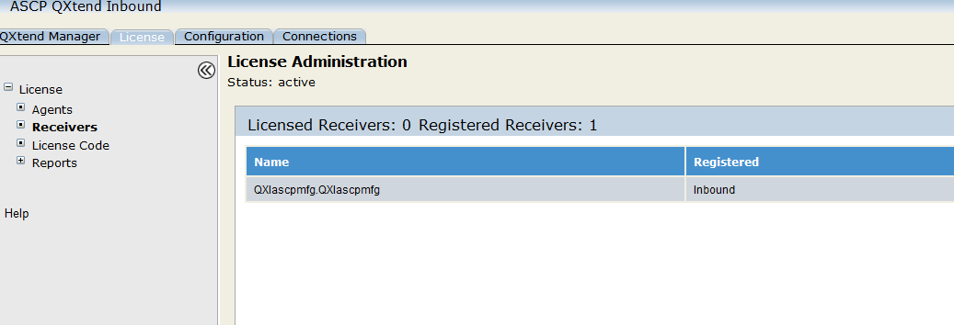

  - license code : This allows you to enter license codes for valid user types, such as MFG/PRO.
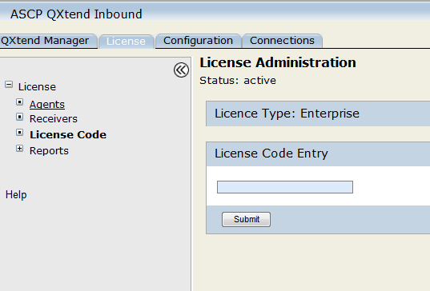

  - reports :
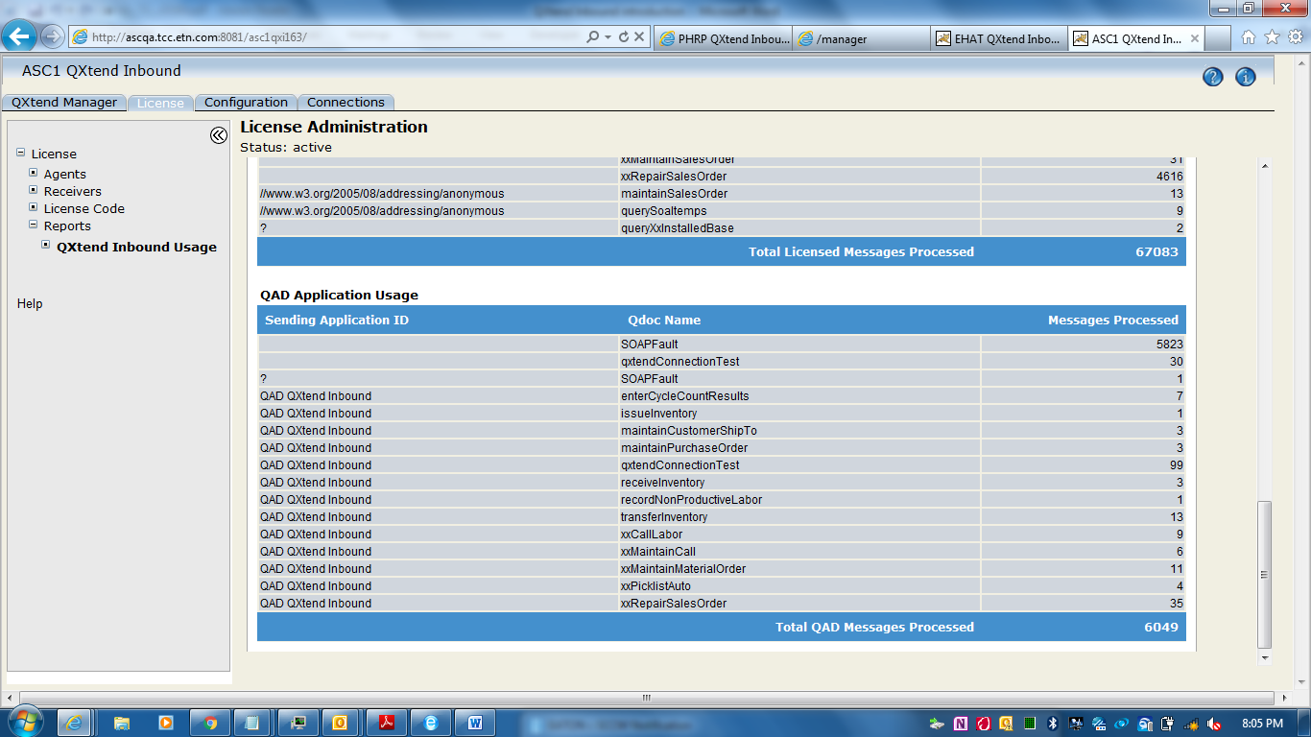

- Configuration
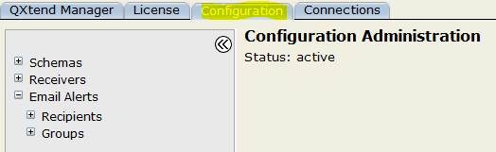

  - SCHEMAS : QXI allows APIs to be added, modified (only certain details), or deleted. The schemas define the API. An API has two schemas; one schema defines the content of the request message, the other defines the content of the response message.
Visible APIs in QXI can be grouped into two types: standard and custom
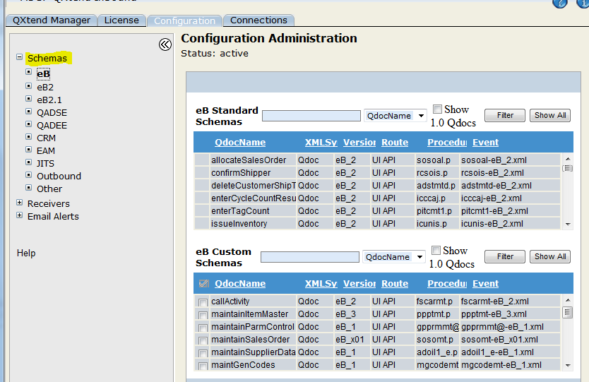

  - Receivers : A receiver serves four primary purposes:
- Identifies the application instance
- Identifies the QAD application version
- Defines the APIs supported
- Receiver-level authentication

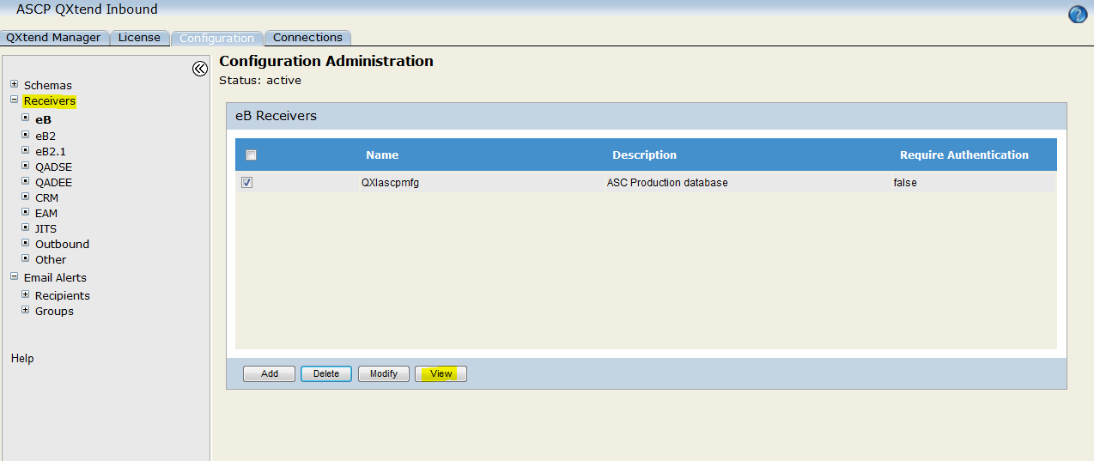

After clicking Add :
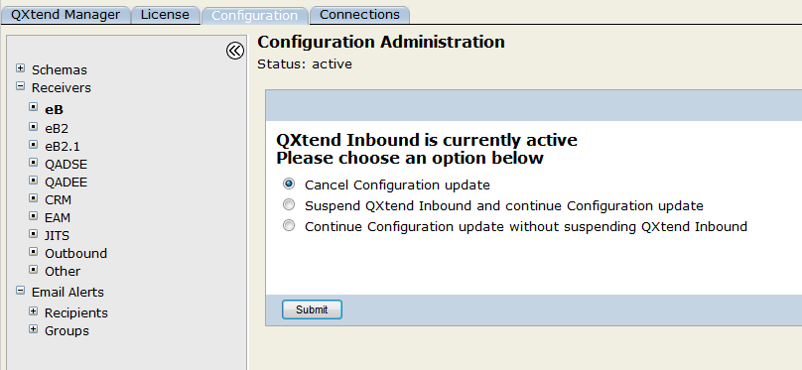

After clicking View:

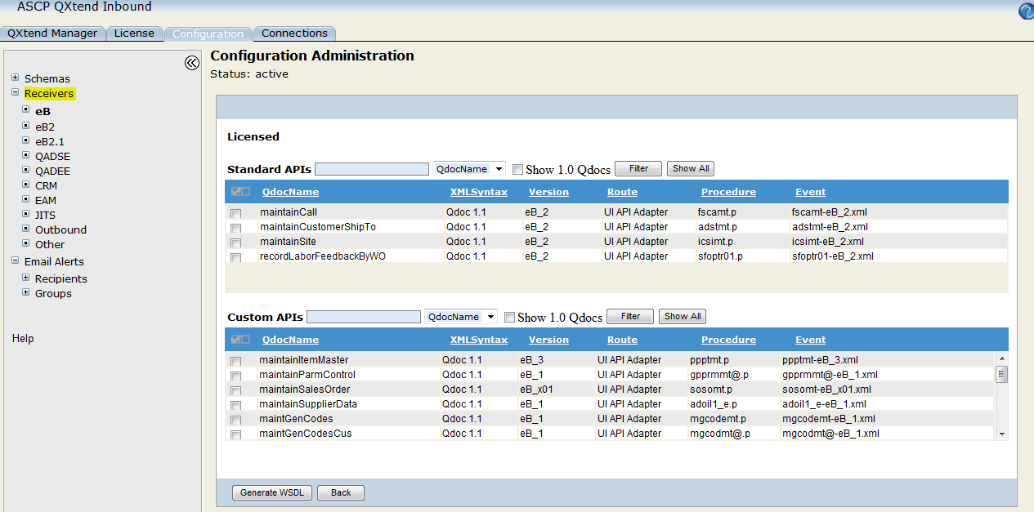

The system displays two lists of APIs.
The Standard APIs list contains all APIs provided by QAD for use with QXtend.
The Custom APIs list contains the APIs developed specifically for the customer.

After clicking Modify:

Cannot change : name assigned to a receiver.(re-create)
Can change : the description, Require Authentication setting, and Licensed/Licensed Domains setting of a receiver, the list of supported APIs.

  - email alerts : The e-mail alerts feature allows specified recipients to receive e-mail alerts that are raised by QXI for events relating to specific receivers, domains, and APIs.
Recipients :
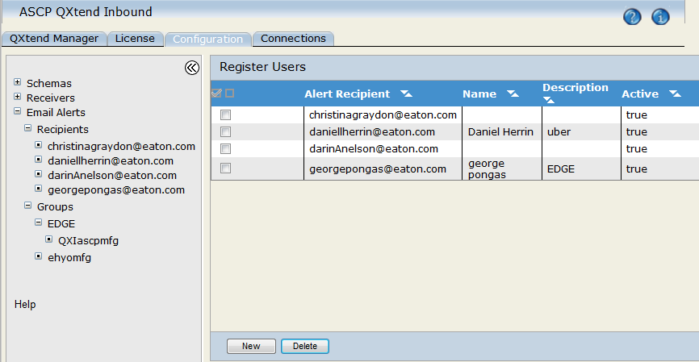

Groups :
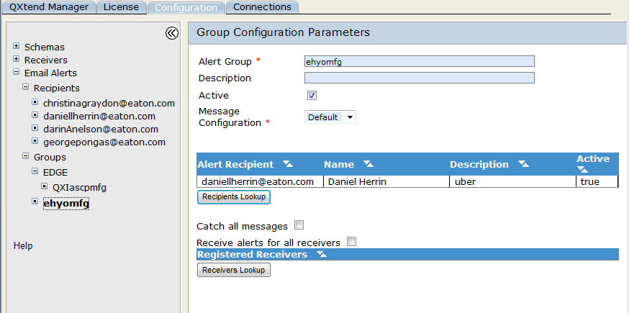

- Connections
  - functions :
- Launch connection pool manager :

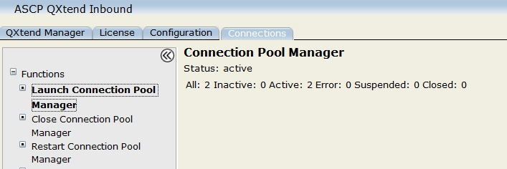

- Close connection Pool manager :
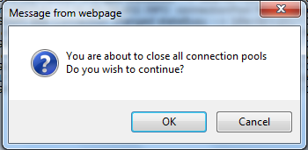

- Restart connection Pool manager :

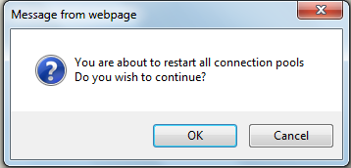

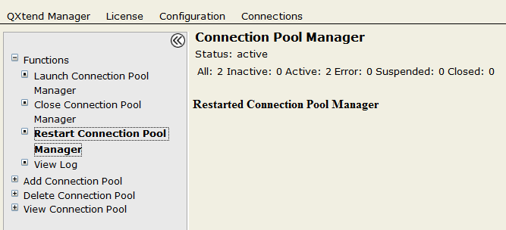

- view log :

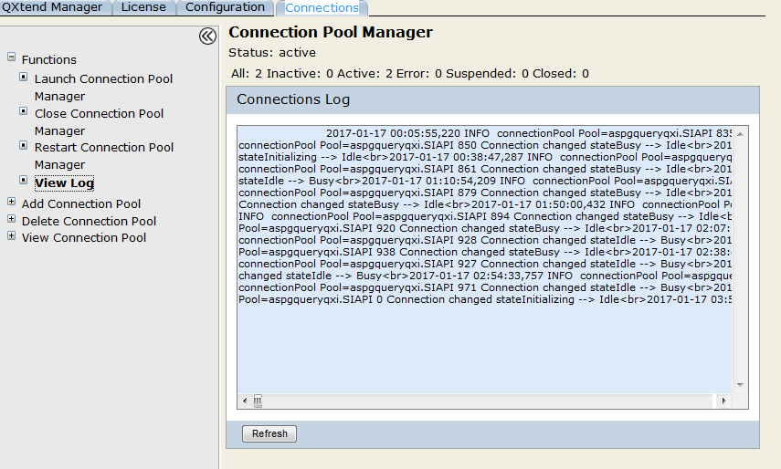

  - add connection pool
The Connection Pool Manager controls telnet connection pools between QXI and your QAD Enterprise Applications and other application sessions. Each connection pool is identified by the type of user it serves—UI API, JITSAPI, SIAPI, or Fin API—and by a pool name, the host machine and port, and a system user.

- Add uiapi adapter : This type leverages a telnet connection to log in to the QAD application and load data from QXtend.
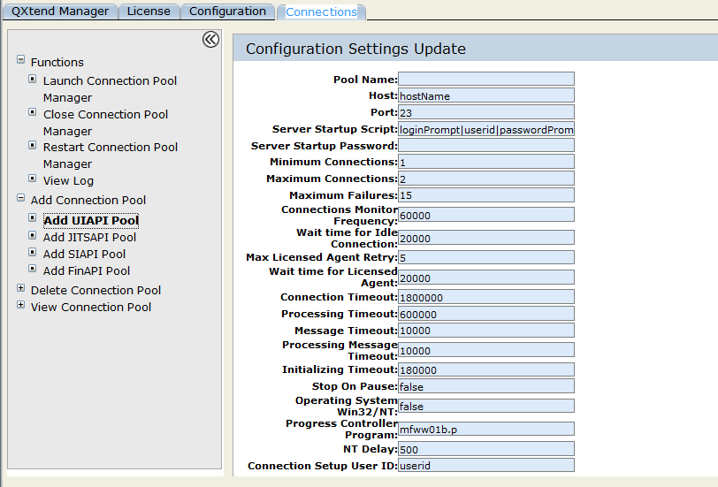

- Add jitsapi pool :

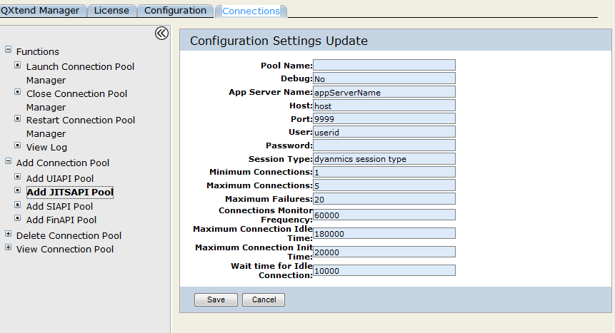
- Add siapi pool : This type uses a the Progress AppServer technology to execute QAD Business Services without using a telnet session and therefore requires a different set of connection parameters to access the services.

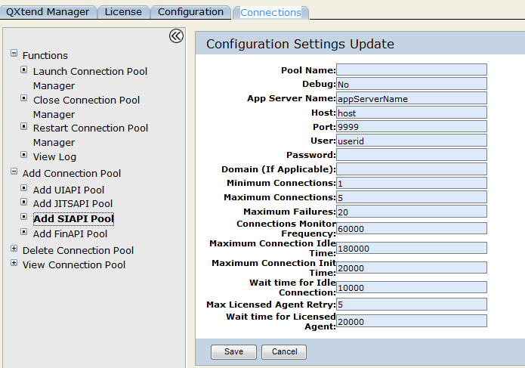

- add finapi pool : for financial app server
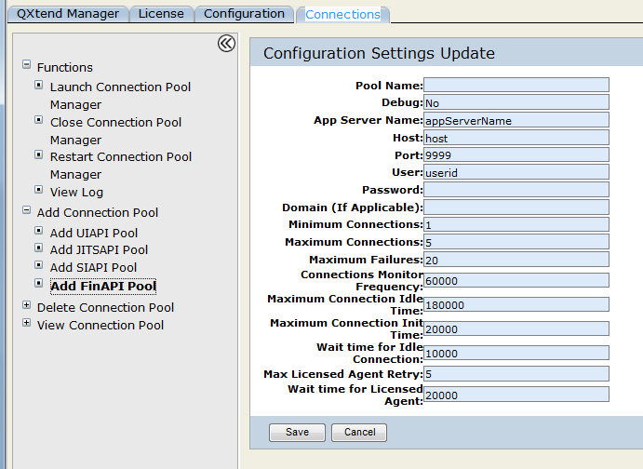

  - Delete connection pool

  - view connection pool

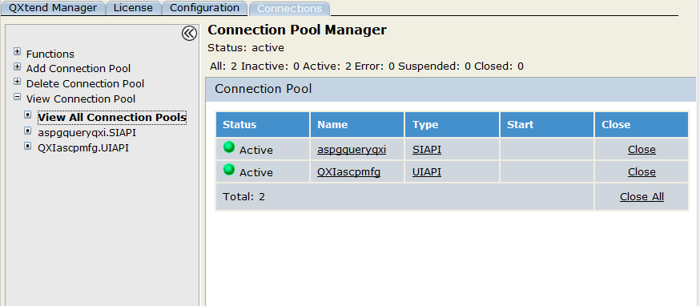

On clicking specific connection pool , we get options :
Functions :
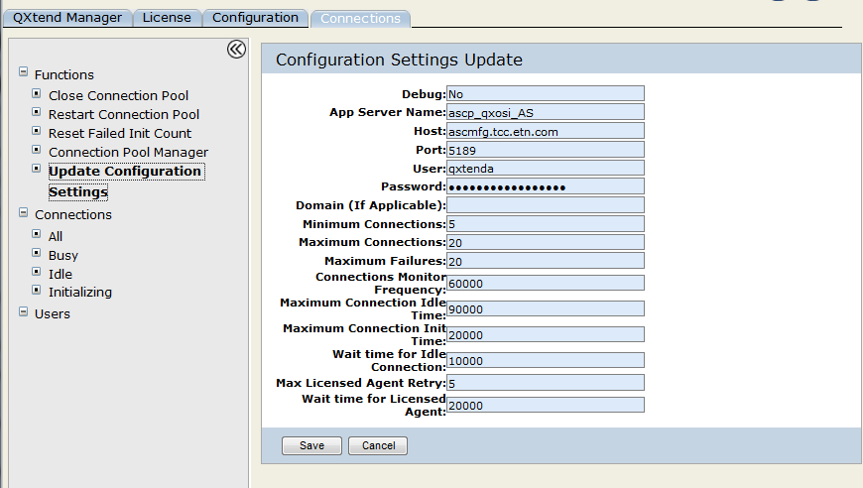

- Functions
Under functions, we have
- Restart Server : This shuts down QXtend Inbound and restarts it, using the Tomcat restart link.
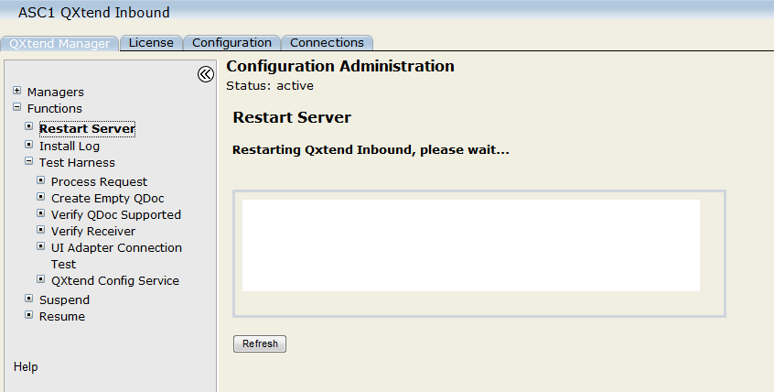
After some time
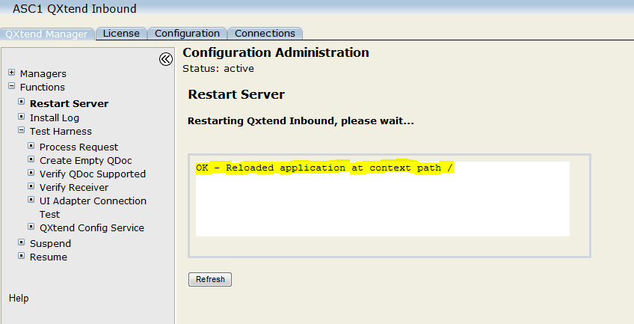

- Install Log This displays qdocInstall.log. The log is updated each time the QXI Web application is started, stopped, or reloaded. The log is stored in:
TOMCAT_HOME/webapps/qxtendserver/WEB-INF/logs
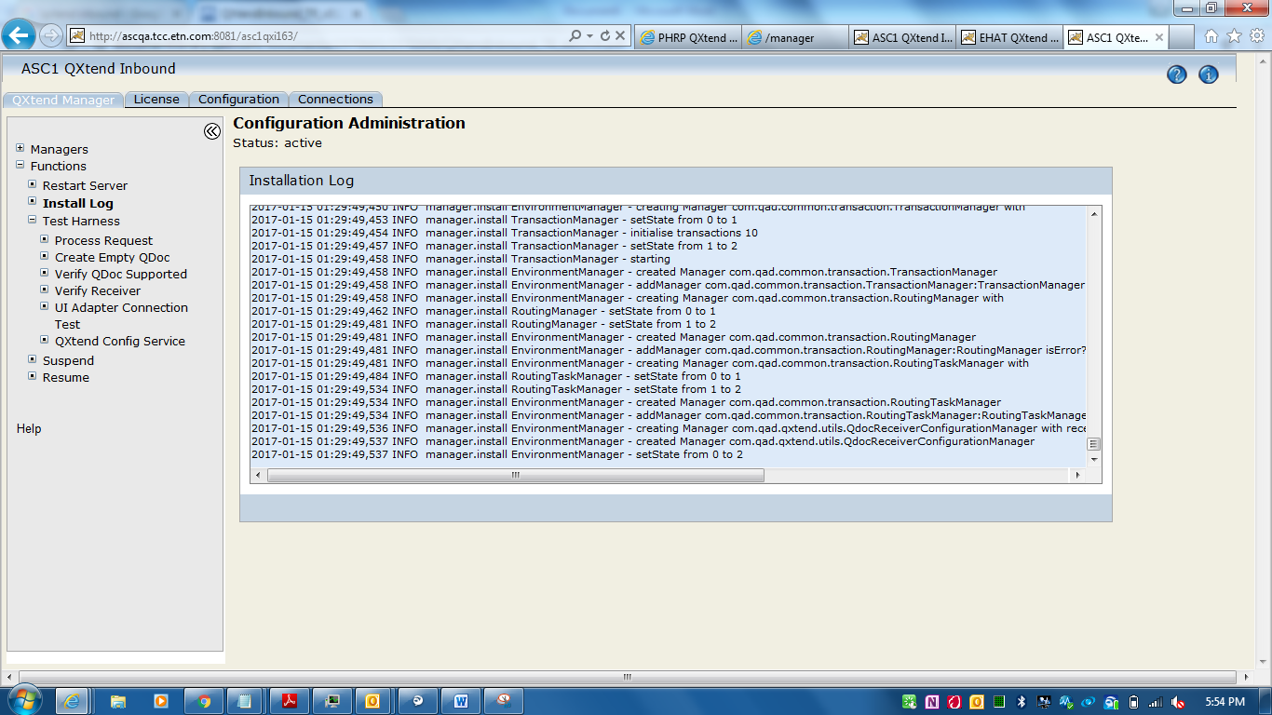

- Test Harness The test harness provides an interface you can use to run through the entire request-response process using sample QDocs.

- Suspend : This shuts down the QXtend services to allow an administrative update, such as configuration changes.

- Resume : This restores QXI services following administrative changes.

[Type the closing]
Regoti, Sujata
[Type the sender title]
QXtend Inbound introduction

